Name: | ____________________________________ |  | Date:_________
 | Year 11 Foundations Mathematics  $\frac{ }{40}$  Test 5 - 2019  Topic – Addition and Subtraction of Whole Number and Money
Total Time: | 25 minutes
Weighting: | 3%
Equipment: | None
Answer all questions in the space provided.

A cooking class are making chocolate chip biscuits. The ingredients for the recipe are shown below.

Chocolate Chip Biscuits
150g softened butter
cup caster sugar
cup brown sugar
1 teaspoon vanilla extract
1 egg
cups plain flour
cup dark chocolate bits
cup milk chocolate bits

- [2 marks]
Complete the following statements about the ingredients. The first one has been done for you to demonstrate what you need to do.
  - < , so this recipe uses more brown sugar than caster sugar.
  - , so this recipe uses caster sugar than dark chocolate chips.
  - , so this recipe uses brown sugar than milk chocolate chips.
- [3 marks]
  - Write all the fractions from this recipe in order from smallest to largest. The fractions are
, , , ,
  - Which ingredient has the largest fraction?

- Circle all of the halves below. How do you know that they are half?
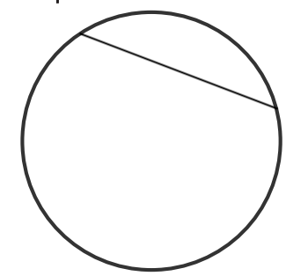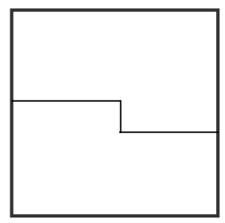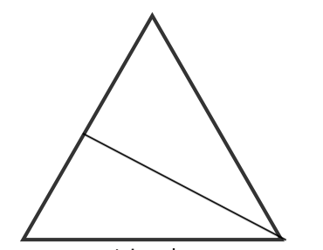

- Divide the following shapes into the listed fractions below





Thirds Halves Quarters

- John was eating a pizza, cut into pieces of 8. Sam was eating pizza, but cut into pieces of 6. If John and Sam both ate 5 slices, who had more total pizza?

- Most athletics stadiums have a 400m racetrack, which when ran 4 times creates a 1-mile run. Because each lap is ¼ of a mile, the first lap is a quarter mile, the second lap is a half mile, third lap is ¾ of a mile and so on. David decides that he wants to run 10 miles this week. So he records the number of quarters he runs:
DAY | Monday | Tuesday | Wednesday | Thursday | Friday
Quarters | $$\frac{5}{4}$$ | $$\frac{7}{4}$$ | $$\frac{6}{4}$$ | $$\frac{10}{4}$$ | $$\frac{8}{4}$$

- How many quarters did David run?

- When the numerator is bigger than the Denominator, we call this an improper fraction. Write the improper fraction for the number of quarters David ran below.

- If every 4 quarters, David runs 1 mile, how many miles did he run?

- Did David achieve his goal? If not, how many quarters does he need to run to get there?

